**Q4. Difference between Justify-items and Justify-self**

Justify-items works on parent or container level it applies to all the elements in the grid container.

Justify-items attributes

* + Stretch
  + Center
  + Start
  + Left
  + End
  + Right
  + Overflow-alignement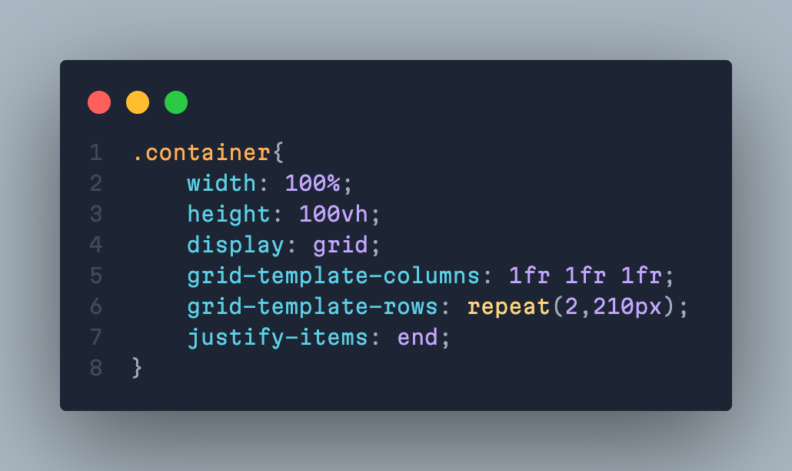

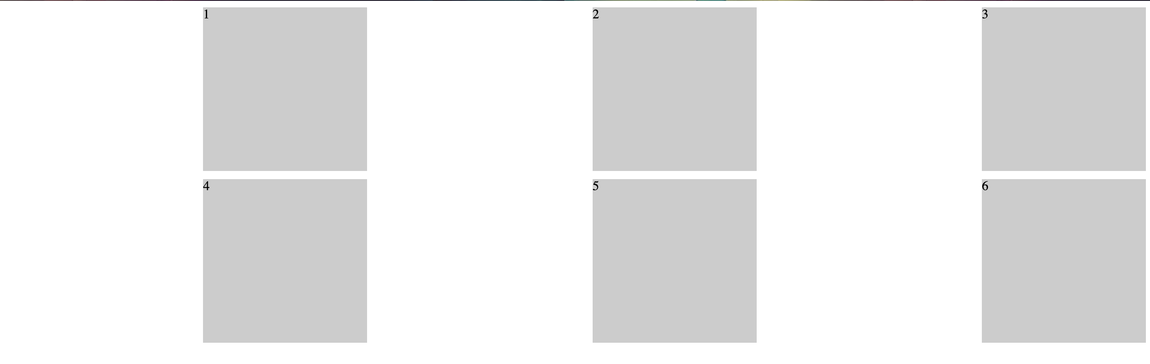

Justify-Self is a child level property which is applicable for child level element in the grid-container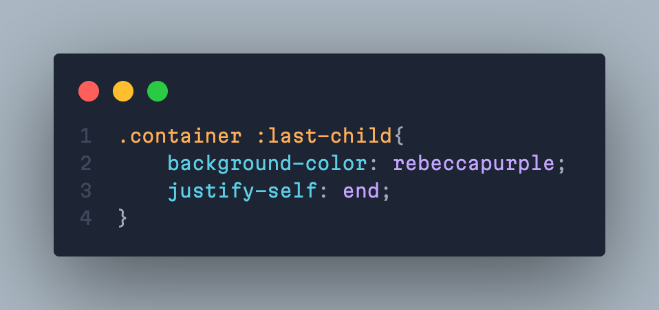

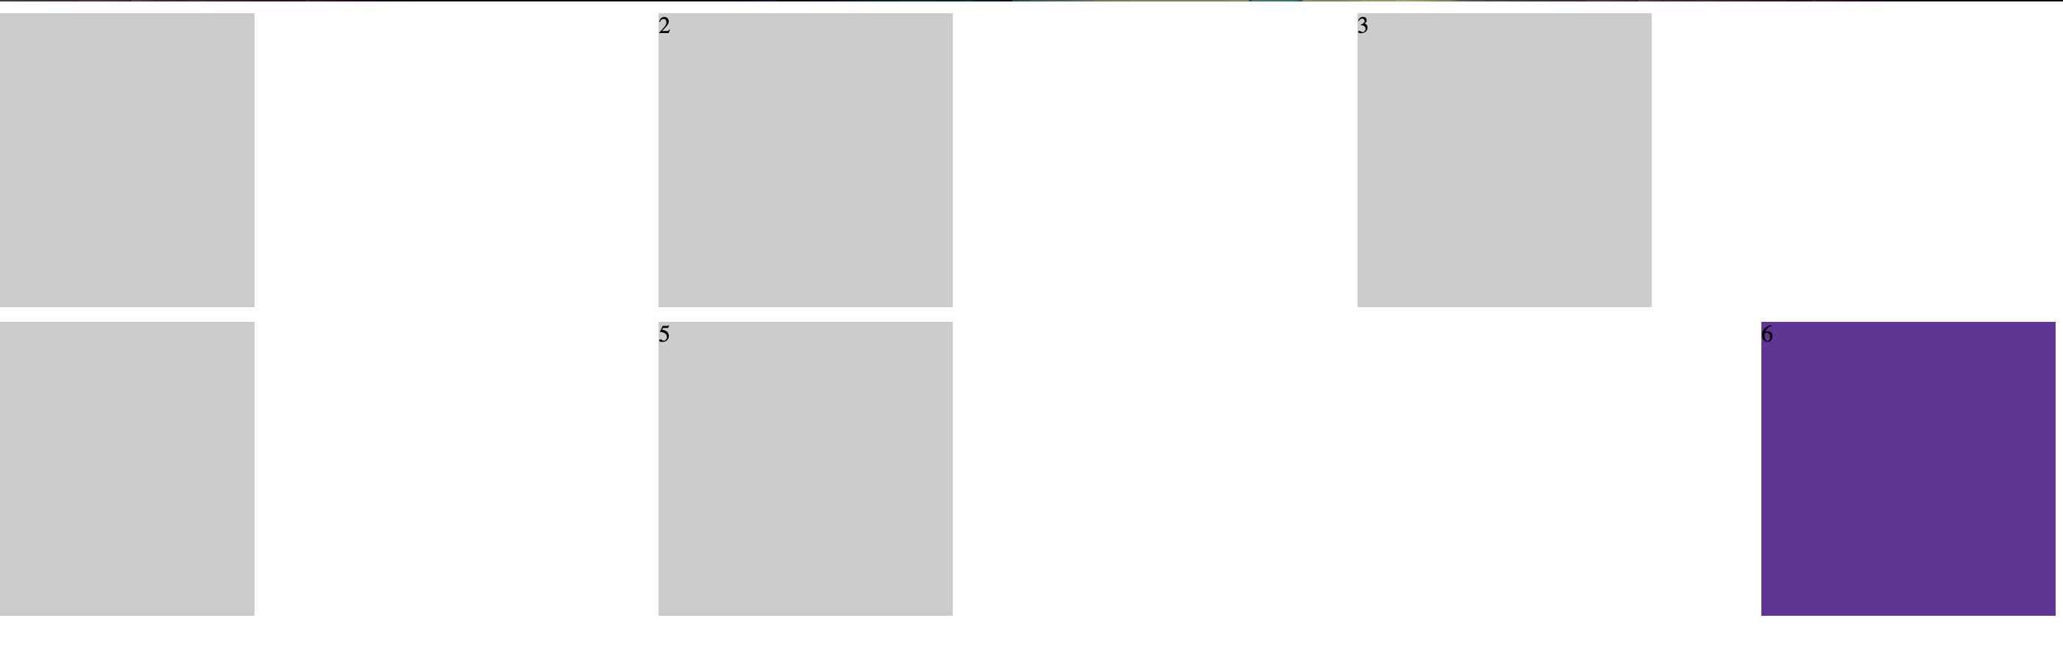

Here we have targeted the last element in the I can change the element alignment within the grid-container.

Justify-items attributes

* + Stretch
  + Center
  + Start
  + Left
  + End
  + Right